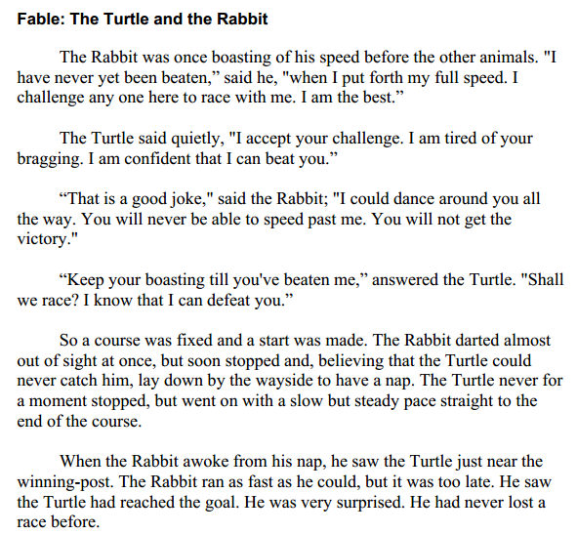
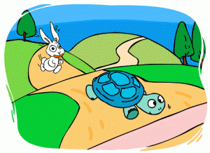
Grade 3 Unit 4 CFA

The Grasshopper and the Ant
The leaf was heavy. Ant struggled to carry it toward his family’s home. From behind him, he heard someone laugh. It was Grasshopper.
“It’s a beautiful summer day, “said Grasshopper. “Why don’t you put your work down and play? There will be time later to gather food.”
“It is a beautiful day,” replied Ant. “But if I don’t work on warm days, my family will not eat on cold days.”
So it went, day after day, week after week. Every time Grasshopper saw Ant, he laughed. “Work, work, work! There’s more to life than work.”
Summer came to an end. The nights became cool. Ant kept busy. He wanted to gather as much food as he could before the coming winter. Grasshopper, too, felt the chill of autumn. He began to look around for things to gather. There was not much left. And time was running out.

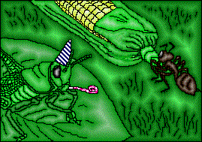
Finally, the snows came. Ant huddled with his family in the warmth of their hill. They ate leaves until they were full. They played games. At night, they slept well. Grasshopper, meanwhile, grew hungry and weak.

