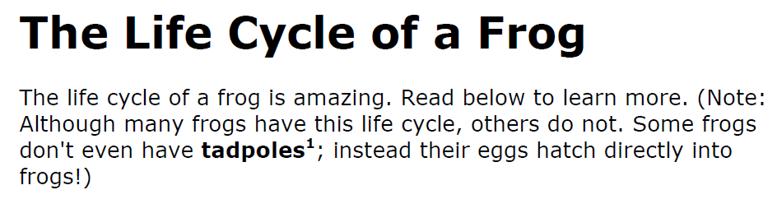
Directions: Read the passage about The Life Cycle of a Frog and then answer the questions.

