Setting up an A&A Account

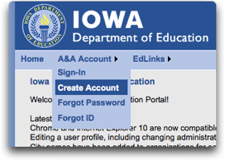
Each person who will access Iowa TIER in 2014-2015 to administer the FAST assessment needs to set up their own A&A account, using their district email address. Eventually, this account will be paired up with information from your SIS (Infinite Campus) to allow access to Iowa TIER. Below are brief directions for setting up your account. Please read this entire page before you start the process.

- Go to https://portal.ed.iowa.gov

- Click “A&A Account”>“Create Account” from the top menu bar

- Enter your First Name and Last Name. Click “Register”
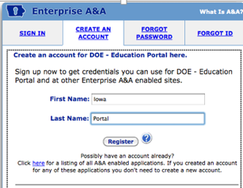

- Enter your dmschools.org email in the Single Sign-On box.
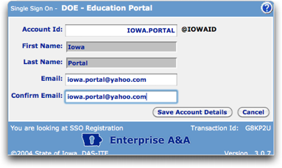
- You will only need one A&A account, even if you need access to multiple Education Portal applications or need access for more than one organization.
- The Account ID name is for individual use, not groups. A&A loins are specific to an individual and should NOT be “shared” or “group” logins. In accordance with State security requirements, access to applications and the permissions granted therein are bound to an individual, not a collection of users. Please do not share logins or passwords!
- A&A will create an Account ID with the tag of @IOWAID at the end. You should enter the entire Account ID (including the "@IOWAID" suffix) when logging in.
- The Account ID is not case-sensitive: "MYNAME@IOWAID" is the same as "myname@iowaid".
- Spaces and most special characters are not allowed. All invalid characters and spaces will be stripped from the Account ID. Special characters allowed are: _(underscore)-(hyphen)+(plus).(period).

IMPORTANT: If you get an error message that says "Sorry, that Account ID already exists", someone else with the same name has already created an account. You will need to modify the 'firstname.lastname' format. Try adding a middle inital, a number, or removing the period between names. For example, there can only be one 'mary.smith@iowaid' account. Contact the DAS-ITE Service Desk if you need personal assistance.
Email: ITE.Servicedesk@iowa.gov Phone: 515-281-5703 or 1-800-532-1174
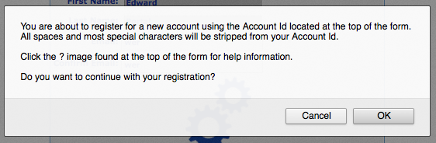
- Once you have checked the information for accuracy, click "Save Account Details". A message box will appear stating you are creating a new account. Press "OK" to continue. The account ID will be your login ID for all A&A applications.

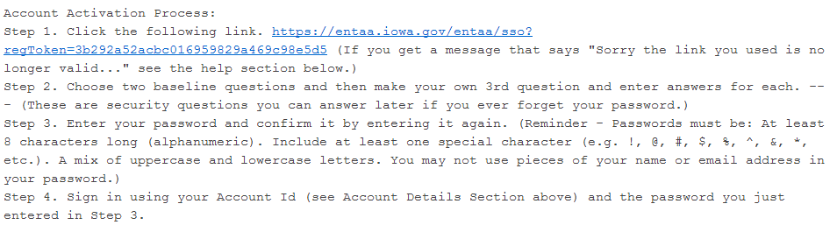
- You will need to go to your @dmschools.org email to follow the account activation link.

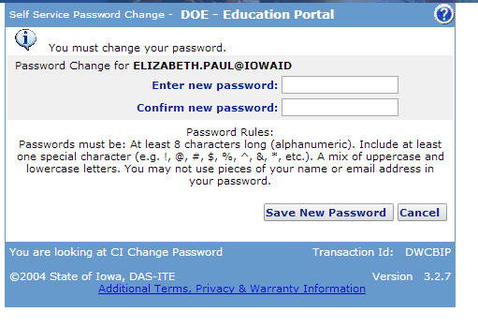
- Enter and confirm a password. Passwords must be at least 8 characters, include a special character (!, @, #, $, %, ^, &, *, etc), and a mix of uppercase and lowercase letters.

Click “Save New Password”

RECORD YOUR ACCOUNT ID and PASSWORD on the “Quick Login for Universal Screening” document on the following page.

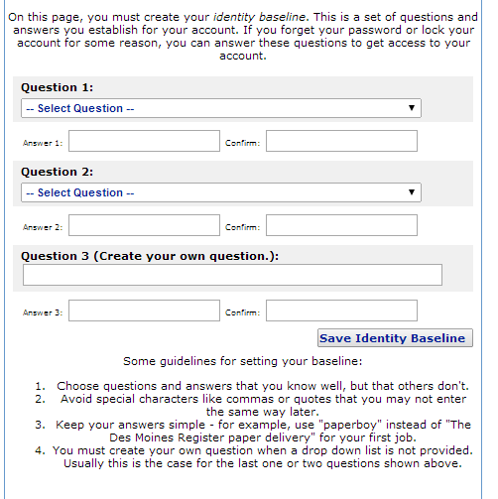

Select/Create security questions with appropriate answers. If you forget your password or lock your account, you can answer these questions to gain access to your account.

Click “Save Identity Baseline.”

