Standards Referenced Grading (SRG) Leadership Team:
We are currently working to identify a teacher, instructional coach, dean or principal from each building to serve on our SRG leadership team this year. This individual will serve as a building contact and support as we move forward with this work in elementary. They will receive training on the rationale and theory surrounding Standards Referenced Grading and will work to articulate elementary guidance for the 6 guiding practices for grading that have already been established in Grades 6-9. This leadership team will also break into 3 sub-committees that will focus on the following:
1. Reporting Structures (including Infinite Campus and Report Cards)
2. Development of Professional Development Modules for School Use
3. Preparing Stakeholder Communications (i.e. Parents, Community)

Our leadership team will meet from 8:30-3:30pm on Monday, November 3rd and then sub-committees will meet for 1-2 hour sessions in the evenings as needed. We will then reconvene our entire leadership committee again in January. If you have not already done so, please respond to Carlyn’s email regarding your school’s representative for this committee.

Please Note: All principals and instructional coaches will also receive training on the rationale and theory surrounding SRG at our Teaching and Learning meetings later this year.

The SCHOOL BUS has arrived! Revolve Student Resources:
In an effort to better support student access to the HP Revolves, a “Student Resources” desktop icon has been pushed out to all Revolves. This icon will take students directly to a webpage (elementarystudentresources.dmschools.org) of student log-ons and grade level resources for independent practice. Please visit the following video link for more information: https://www.youtube.com/watch?v=aHqOo0vcc6E&list=UUN7ozGA_MsscmKty1c7Zhxw. If you have questions about this site or have not received the icon on all Revolves, please contact your Technology Coordinator.
SAM System Shutdown:
SAM (Scholastic Achievement Manager) will be temporarily shut down for upgrades the week of October 20-24. Please contact J Starr if you have questions or concerns. Thank you for your patience as we work to make our system more efficient and reliable.

Removal of Discontinued Textbooks:
Central Stores is now ready to collect discontinued textbooks, including Math Expressions and Investigations. In order to initiate this removal, please complete the steps below. If you have questions, please contact Tom Sheehy (Central Stores) or Carlyn Cox.
- Collect and organize materials that need removed. If using boxes, please ensure they are study and are not overloaded. (**Note: Please do NOT pack discontinued materials with current materials.)
- Complete the electronic transfer form: http://fs8.formsite.com/DMPSchools/form81/index.html. The “deliver to location” is Central Stores. Specific items do not need to be listed on this form, however please indicate the quantity of materials and indicate that they are DISCONTINUED.
- Place materials in a central location that is easily accessible for pick-up.

Iowa Core Website:
http://IowaCore.gov is a new website created to increase public understanding of the Iowa Core standards and help educators put the standards into practice in schools statewide. On this site, you will find information regarding the Iowa Core Curriculum including grade level parent letters that concisely provide student expectations in parent-friendly language. Please consider how you will utilize these parent letters to increase understanding of the Iowa Core standards.

Fast Assessment:
Just as a reminder, Chapter 62 of the Early Literacy Initiative (ELI) requires all “at risk” students to be progress monitored through FAST; however, due to the delay in the release of benchmark scores from the Department of Education, DMPS will hold on requiring all “at risk” students to be progress monitored through FAST until the fall of 2015. If you have further questions about the DMPS implementation plan, please see the handout from our summer training session “DMPS and ELI Questions” (linked here and found on our elementary Teaching and Learning website). If your school would like more information on implementing progress monitoring this year through FAST, please contact Liz Griesel.

Science/Social Studies Materials Exploration Committee:
Our Science and Social Studies Materials Review Committee met October 6th to discuss plans for evaluating resources for K-5. Our focus will be on reviewing digital materials, which include resources that can be used with our interactive projectors and student devices. We will continue to provide updates on our progress as the year continues. If you have questions about this process, please contact Liz Griesel or Carlyn Cox.

Accessing 2015 Go Math! on Think Central:
We are working with HMH to clean up the Dashboard on Think Central because there are many, many resources to view at this time. Until then, here is how to view the 2015 Go Math! resources:
- Log in to Think Central
- Click the arrow next to word Resources
- Enter Mathematics, Grade Level, and Language into the dropdown menus.
- For Program select: NL Go Math (National Go Math)

You should now only see the 2015 Go Math resources. If you have questions about Think Central, please contact J Starr or Anna Taggart.

Go Math! Interactive Student Edition:
The Interactive Student Edition is now available on Think Central. This is where the Engage Digital Lessons are accessible.
Here are the directions to accessing the Engage Digital Lesson:
- Log in to Think Central
- Click the arrow next to word Resources
- Enter Mathematics, Grade Level, and Language into the dropdown menus.
- For Program select: NL Go Math (National Go Math)
- Find Interactive Student Edition (Teacher)
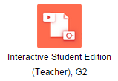
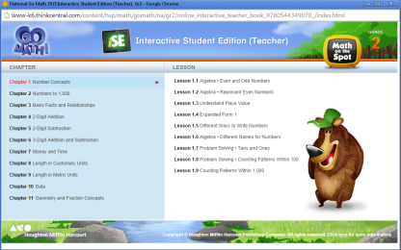

- Another window will appear – select the desired Chapter and Lesson.

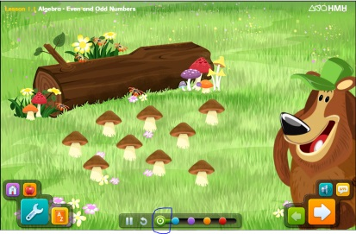

- The Interactive Student Edition will pop up. The Engage section is the Green Circle. It is VERY simple. Teachers should use professional judgment on when to use this resource.

