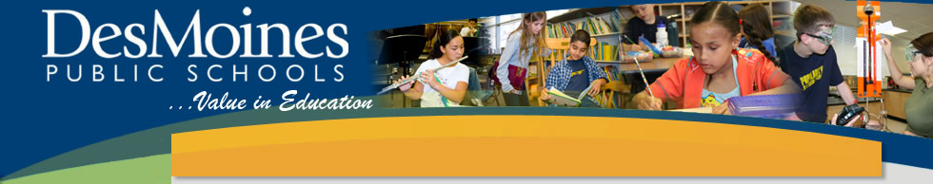
Literacy/Content Areas & Technology Training
8:30-4:30pm

Professional Development Objectives:
- Learn about the available technology resources for Literacy and Content Areas instruction.
- Collaborate, plan, and explore with the available technology resources.

Agenda:
8:30am Welcome & Agenda Overview
8:35am 2014-2015 Literacy Curriculum Guides & Assessment Plan
8:50am Technology and Literacy
9:00am Teacher-Created/CUTEE Resources
9:30am Exploration: Scavenger Hunt & Collaborative Planning & BREAK
9:55am “BRAIN BREAK”
10:00am Think Central Resources
10:30am Exploration: Scavenger Hunt & Collaborative Planning
11:00am Smart Exchange Resources
11:30am Exploration: Scavenger Hunt & Collaborative Planning

12:00pm-1:00pm Lunch*
*Individuals who plan to take this as part of the 2 day course for 1 AEA License Renewal or Drake EDEX Credit must engage in 30 minutes of onsite structured collaboration during this 1 hour lunch break. This time will include opportunities for you to action plan the implementation of new learning.

1:00pm Social Studies Curriculum Guides & Resources
1:45pm Exploration: Collaborative Planning
2:00pm Science Curriculum Guides & Resources
3:00pm Exploration: Collaborative Planning
3:30pm Health Curriculum Guides & Resources
4:15pm Exploration: Collaborative Planning
4:30pm Dismissal

