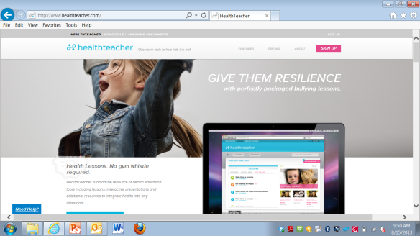
HealthTeacher.com

Activating Your HealthTeacher.com Account
Step 1: Go to www.HealthTeacher.com/activate.
Step 2: Enter Activation Code: desmoinesps-ia and click “Submit”
Step 3: Enter School Email Address & click “Continue”
Step 4: Enter User Information. Enter your First Name, Last Name and the Password dmpshealth. Select your School Name.
Step 5: Click “Submit” and explore HealthTeacher.com!

_ _ _ _ _ _ _ _ _ _ _ _ _ _ _ _ _ _ _ _ _ _ _ _ _ _ _ _ _ _ _ _ _ _ _ _ _ _ _ _ _ _ _ _ _ _

HealthTeacher.com

Activating Your HealthTeacher.com Account
Step 1: Go to www.HealthTeacher.com/activate.
Step 2: Enter Activation Code: desmoinesps-ia and click “Submit”
Step 3: Enter School Email Address & click “Continue”
Step 4: Enter User Information. Enter your First Name, Last Name and the Password dmpshealth. Select your School Name.
Step 5: Click “Submit” and explore HealthTeacher.com!

