Grown Up

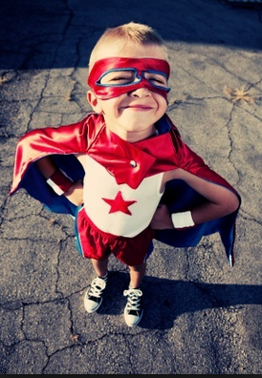
I used to be a superhero,
Soaring high from tree to tree.
With a cape around my shoulders,
I was as happy as could be.

“Grow up,” my brother said.

By four, I’d made a rocket ship.
It took me all the way to Mars.
It started out as a cardboard box,
Before I steered it to the stars.

“Grow up,” my sister said.

At five, I could read and write
in every language ever heard.
The pictures gave me all I needed.
And crayon scrawls stood in for words.

“Grow up,” my best friend said.

At six, I put my cape away.
At seven, a box was just a box.
By eight, I read and wrote with ease.
I could tell the time on clocks.
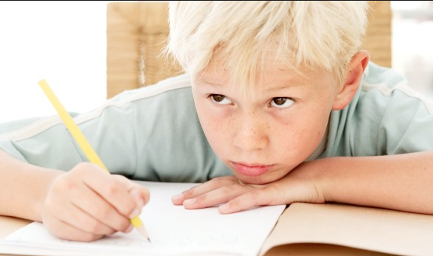
“You’re growing up,” my mother said.

I miss my cape. Sometimes I think
that boxes still could make cool forts.
But I have no time for make believe
I’m busy writing school reports.

I don’t always like being grown up.

