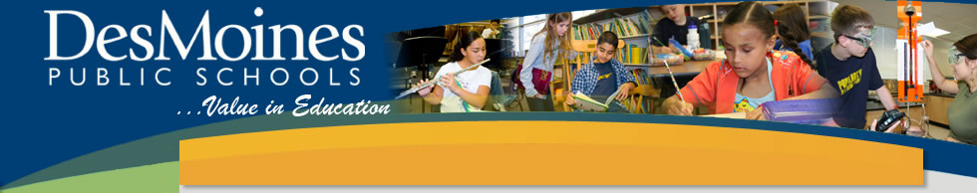
Blended Learning & Technology Training
8:30am-12:00pm

Professional Development Objectives:
- Learn about the Blended Learning in Des Moines Public Schools.
- Collaborate, plan, and explore with Go Math resources.
- Learn about the new technology in the elementary buildings of Des Moines Public Schools.

Agenda:
- Welcome
- New Technology
- Blended Learning in DMPS
- ThinkCentral and Go Math Interactive Whiteboard Lessons
- Summary of Learning

12:00pm-1:00pm Lunch*
*Individuals who plan to take this as part of the 2 day course for 1 AEA License Renewal or Drake EDEX Credit must engages in 30 minutes of onsite structured collaboration during this 1 hour lunch break. This time will include opportunities for you to action plan the implementation of new learning.

