2nd Grade Unit 2 CFA (non-fiction)

Read the passage below.
Name:

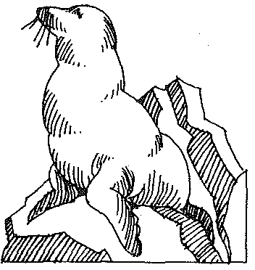

Sea lions are large mammals. They live in the ocean. They are smart and love to play.
You can watch sea lions at the ocean or in zoos. Watching them is more fun than watching TV.

Sea lions can go under the water for as long as 20 minutes at a time. Then they must come up to get air. They can even jump out of the water. It is fun to see!

* They are called sea lions, but they look more like dogs than lions. They sound like dogs, too. They make a barking noise. Young sea lions are called pups. Young dogs are called pups, too.

Male sea lions have a bump on their heads, but females do not. Sea lions are the best mammals in the water!

