2015-2016 Elementary Pacing Calendar
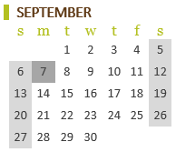
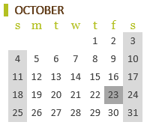
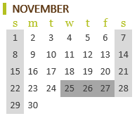
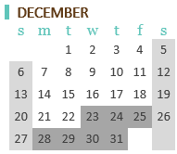
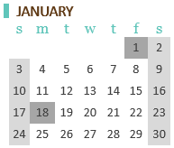
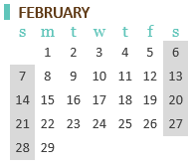
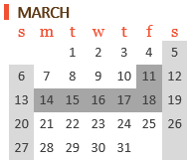
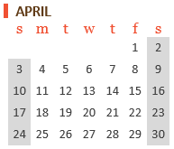
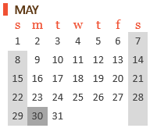

FALL
First Day of School | 8/26/15
Begin Literacy Unit 1 + Math Chapter 1  (*Routines, Expectations, and Assessments can be taught prior to starting or in conjunction with the content) | 8/31/15
FAST Data Collection Due:  Grades K-1: FAST earlyReading Assessment  Grades 2-3: Fast CBM Reading Assessment | 9/7/15 – 10/2/15
SRI/SMI Data Collection Due:  Grades 4-5: Scholastic Reading Inventory  Grade 3-5: Scholastic Math Inventory | 8/26/15 - 9/18/15
Begin Literacy Unit 2 | 10/12/15
District Writing Assessments Data Collection Due:  Grades 3-5: District Writing Assessment Pretest | 9/14/15- 10/30/15
Begin Literacy Unit 3 | 11/23/15

WINTER
SRI/SMI Data Collection Due:  Grades 4-5: Scholastic Reading Inventory  Grades 3-5: Scholastic Math Inventory | 12/7/16 – 1/29/16
District Standards Assessments Data Collection Due:  Grade 1: Writing Standards Assessment  Grades 2-5: Comprehensive Mid-Year Literacy Standards Assessment  Grades K-5: Comprehensive Mid-Year Math Standards Assessment | 1/4/16 – 1/22/16
Begin Literacy Unit 4 | 1/25/16
FAST Data Collection Due:  Grades K-1: FAST earlyReading Assessment  Grades 2-3: Fast CBM Reading Assessment | 1/18/16 – 2/12/16

SPRING
Begin Literacy Unit 5 | 3/7/16
Iowa Assessments: Grades 3-5 | 3/29/15- 4/11/15
Begin Literacy Unit 6 | 4/25/16
FAST District Data Collection Due  Grades K-1: FAST earlyReading Assessment  Grades 2-3: Fast CBM Reading Assessment | 4/18/16 – 5/13/16
District Standards Assessments Data Collection Due:  Grades 1-5: Comprehensive End of Year Literacy Standards Assessment  Grades K-5: Comprehensive End of Year Math Standards Assessment | 5/2/16 – 6/1/16
District Writing Assessments Data Collection Due:  Grades 3-5: District Writing Assessment Posttest | 5/2/16 – 6/1/16
SRI/SMI Data Collection Due:  Grades 4-5: Scholastic Reading Inventory  Grades 3-5: Scholastic Math Inventory | 4/4/16 – 6/1/16
Last Day of School | 6/1/16

